Icklingham Parish Council
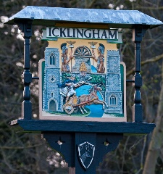
Chair: Cllr Darren Baugh Clerk: Mrs Vikki Austin
25 The Street 21 Mutford Green
Icklingham Lakenheath
Bury St Edmunds Suffolk IP27 9LR
Suffolk IP28 6PS Tel: 01842 861748
Tel: 01638 510449
Email: darrenbaugh@aol.com Email: IcklinghamPC@gmail.com

MEMBERS OF ICKLINGHAM PARISH COUNCIL
Are hereby summoned to a meeting of Icklingham Parish Council to be held on
WEDNESDAY 18 MARCH 2020 at Icklingham Community Centre to commence at 7.30pm

Members of the public are welcome to attend and speak on any item on this agenda for the first 10 minutes of the meeting. They are then welcome to remain and observe the rest of the meeting.

AGENDA

19/20.55 Apologies for absence

19/20.56 To receive any declarations of interest:
56.1. Declaration of any disclosable pecuniary interest in any item of business
56.2. Declaration of any personal and/or prejudicial interest in any items on the agenda
56.3. Written requests for dispensations for disclosable pecuniary interests
56.4. Grants to any requests for dispensation

19/20.57 Confirmation of Minutes of meetings held on 24 September 2019 & 26 November 2019

19/20.58 Follow Up Items
58.1 Defibrillators in phone box
58.2 Playing Fields

19/20.59 Coronavirus

19/20.60 30mph Wheelie Bin Stickers

19/20.61 75th Anniversary – The Second World War

19/20.62 Benches and Planters

19/20.63 Planning Matters

19/20.64 Correspondence received

19/20.65 Financial Matters
65.1 Bank Balances and Bank Reconciliation
65.2 Payments made since last meeting

19/20.66 District Councillor’s Report

19/20.67 County Councillor’s Report

Vikki Austin
Parish Clerk

