Icklingham Parish Council
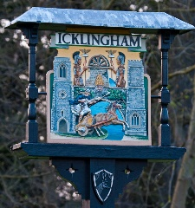
Chair: Cllr Darren Baugh Clerk: Mrs Vikki Austin
25 The Street 21 Mutford Green
Icklingham Lakenheath
Bury St Edmunds Suffolk IP27 9LR
Suffolk IP28 6PS Tel: 01842 861748
Tel: 01638 510449
Email: darrenbaugh@aol.com Email: IcklinghamPC@gmail.com

MEMBERS OF ICKLINGHAM PARISH COUNCIL
Are hereby summoned to a meeting of Icklingham Parish Council to be held on
TUESDAY 27 July 2021 at Icklingham Community Centre to commence at 7.30pm

Members of the public are welcome to attend and speak on any item on this agenda for the first 10 minutes of the meeting. They are then welcome to remain and observe the rest of the meeting.

AGENDA

21/22.1 Apologies for absence

21/22.2 To receive any declarations of interest:
2.1. Declaration of any disclosable pecuniary interest in any item of business
2.2. Declaration of any personal and/or prejudicial interest in any items on the agenda
23. Written requests for dispensations for disclosable pecuniary interests
2.4. Grants to any requests for dispensation

21/22.3 Confirmation of Minutes of meetings held on 30 March 2021

21/22.4 District Councillor’s Report

21/22.5 County Councillor’s Report

21/22.6 Chairman’s Update

21/22.7 Planning Matters

21/22.8 Correspondence received

21/22.9 AGAR

21/22.10 Financial Matters
10.1 Bank Balances and Bank Reconciliation
10.2 Payments made since last meeting

21/22.11 Clerk’s Update

Vikki Austin
Parish Clerk

Published 21 July 2021

