Icklingham Parish Council
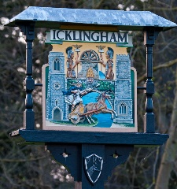
Chair: Cllr Darren Baugh Clerk: Mrs Vikki Austin
25 The Street 21 Mutford Green
Icklingham Lakenheath
Bury St Edmunds Suffolk
Suffolk IP28 6PS IP27 9LR
Tel: 01638 510449 Tel: 01842 861748
Email: darrenbaugh@aol.com Email: IcklinghamPC@gmail.com

MINUTES of the meeting of Icklingham Parish Council
Held on Tuesday 28 January 2020 at 7.30 pm in the Community Centre, Icklingham

Present: Cllr D Baugh (DB) - Chair
Cllr K Baugh (KB) - Apologies
Cllr R Moss (RM)
Cllr V Halford (VH) - Apologies
Cllr M Oakes (MO) - Apologies

Also Present:
0 members of the public

PUBLIC FORUM

None

19/20.31 APOLOGIES
Cllr K Baugh – Apologies – Accepted
Cllr M Oakes – Apologies – Accepted
Cllr V Halford – Apologies – Accepted
Mrs V Austin Clerk – Apologies - Accepted

The meeting did not go ahead due to not being quorate. All items on the agenda will be carried forward to the next meeting, with the exception on of item

19/20.51 - Precept setting

All information was circulated by email for agreement due to the deadline of submitting the request to district council. The precept was agreed to be a 2% increase inline with inflation.

Signed : …………………………………………
Chairman

